Name and Student ID:________________________________________ Lab Section:__

Date:_________________

PRELAB:

Q1. Circuit diagram for a register file with four 2-bit registers.
Please complete the following circuit diagram to implement a register file with four 2-bit registers, one write port, one read port, and one write enable line. Label all inputs and outputs of your circuit. Please use different colors for the different types of wires.

Input bus
Load
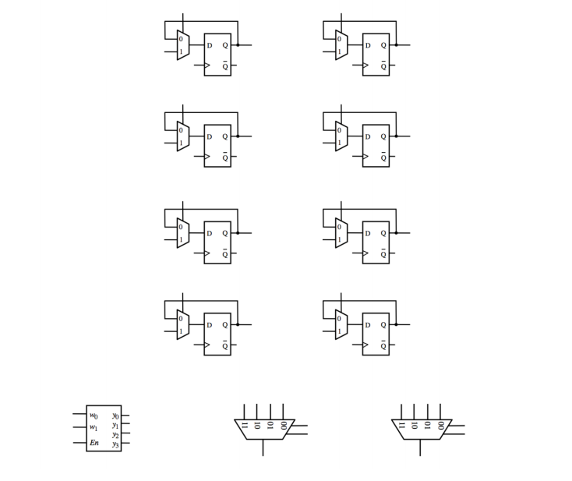
Clock
Output bus

The rest of this lab is about a register file with eight 4-bit registers.

Q2. Write the Verilog code for a 4-bit 8-to-1 multiplexer below.
module Mux8_4b(S2, S1, S0, W0, W1, W2, W3, W4, W5, W6, W7, F);
input S2, S1, S0;
input [3:0] W0, W1, W2, W3, W4, W5, W6, W7;
output [3:0] F;
always@(w0 or w1 or w2 or w3 or w4 or w5 or w6 ow w7)
begin
case({s2,s1,s0})
3’b000: F = w0;
3’b001: F = w1;
3’b010: F = w2;
3’b011: F = w3;
3’b100: F = w4;
3’b101: F = w5;
3’b110: F = w6;
3’b111: F = w7;
Endcase
End
endmodule

Q3. Write the Verilog code for a 3-to-8 decoder in the space below.
module Decoder3to8(EN, W2, W1, W0, Y0, Y1, Y2, Y3, Y4, Y5, Y6, Y7);
input EN, W2, W1, W0;
output Y0, Y1, Y2, Y3, Y4, Y5, Y6, Y7;
module threetoeight (en,w2,w1,w0,y0,y1,y2,y3,y4,y5,y6,y7);
input en,w2,w1,w0;
output reg y0,y1,y2,y3,y4,y5,y6,y7;
always @ (en,w2,w1,w0)
begin
y0=0;
y1=0;
y2=0;
y3=0;
y4=0;
y5=0;
y6=0;
y7=0;

if (en == 1'b1)
begin
case({w2,w1,w0})
3'b000: y0 = 1;
3'b001: y1 = 1;
3'b010: y2 = 1;
3'b011: y3 = 1;
3'b100: y4 = 1;
3'b101: y5 = 1;
3'b110: y6 = 1;
3'b111: y7 = 1;
endcase
end
end
endmodule

Q4. Using copies of the decoder, multiplexer, and 4-bit register from the previous steps, write the Verilog code that will provide the functionality of a register file with eight 4-bit registers. Your code should contain the decoder, the 4-bit registers, the multiplexers, and additional connections to make the whole circuit operational.

module regfile(DATAP3, DATAP2, DATAP1, DATAP0, DATAQ3, DATAQ2, DATAQ1, DATAQ0,
RP2, RP1, RP0, RQ2, RQ1, RQ0, WA2, WA1, WA0, LD_DATA, WR, CLRN, CLK);

// address and control ports
input RP2, RP1, RP0, RQ2, RQ1, RQ0, WA2, WA1, WA0, WR, CLRN, CLK;

// input data port
input [3:0] LD_DATA;

// output data ports
output DATAP3, DATAP2, DATAP1, DATAP0, DATAQ3, DATAQ2, DATAQ1, DATAQ0;

// wire declarations
wire [3:0] DATAP, DATAQ;

DFF_4bit REG0 (.CLK(CLK), .RST(CLRN), .D(LD_DATA), .EN(EN0), .Q(DATA0));
DFF_4bit REG1 (.CLK(CLK), .RST(CLRN), .D(LD_DATA), .EN(EN1), .Q(DATA1));
DFF_4bit REG2 (.CLK(CLK), .RST(CLRN), .D(LD_DATA), .EN(EN2), .Q(DATA2));
DFF_4bit REG3 (.CLK(CLK), .RST(CLRN), .D(LD_DATA), .EN(EN3), .Q(DATA3));
DFF_4bit REG4 (.CLK(CLK), .RST(CLRN), .D(LD_DATA), .EN(EN4), .Q(DATA4));
DFF_4bit REG5 (.CLK(CLK), .RST(CLRN), .D(LD_DATA), .EN(EN5), .Q(DATA5));
DFF_4bit REG6 (.CLK(CLK), .RST(CLRN), .D(LD_DATA), .EN(EN6), .Q(DATA6));
DFF_4bit REG7 (.CLK(CLK), .RST(CLRN), .D(LD_DATA), .EN(EN7), .Q(DATA7));

Decoder3to8 WR_DECODE (.EN(1'b1), .W2(WA2), .W1(WA1), .W0(WA0), .Y0(EN0), .Y1(EN1), .Y2(EN2), .Y3(EN3), .Y4(EN4), .Y5(EN5), .Y6(EN6), .Y7(EN7));
Mux8_4b RD_PMUX (.S2(RP2), .S1(RP1), .S0(RP0), .W0(DATA0), .W1(DATA1), .W2(DATA2), .W3(DATA3), .W4(DATA4), .W5(DATA5), .W6(DATA6), .W7(DATA7), .F(DATAP));
Mux8_4b RD_QMUX (.S2(RQ2), .S1(RQ1), .S0(RQ0), .W0(DATA0), .W1(DATA1), .W2(DATA2), .W3(DATA3), .W4(DATA4), .W5(DATA5), .W6(DATA6), .W7(DATA7), .F(DATAQ));

assign DATAP0 = DATAP[0];
assign DATAP1 = DATAP[1];
assign DATAP2 = DATAP[2];
assign DATAP3 = DATAP[3];

assign DATAQ0 = DATAQ[0];
assign DATAQ1 = DATAQ[1];
assign DATAQ2 = DATAQ[2];
assign DATAQ3 = DATAQ[3];

endmodule

Prelab TA Initials: _________
LAB:

Fill in the characteristic table for the one-bit parallel access register.
In | Load | Out
0 | 0 | HOLD
1 | 0 | HOLD
0 | 1 | 0
1 | 1 | 1

Fill in the table with steps that will load the registers as follows: Reg[0]=F, Reg[1]=A. Reg{2]=C. Reg[3]=E, Reg[4]=2, Reg[5]=7, Reg[6]=6, and Reg[7]=1.

LD_DATA | WA
F | 000
A | 001
C | 010
E | 011
2 | 100
7 | 101
6 | 110
1 | 111

4.0 Register File with Eight 4-bit Registers

Screenshots: _________

Fill in the table below with the result produced by the register file (with CLRN=1).

LD_DATA | Sel | WA | RP | RQ | CTRL | WR | Effect
0110 | 0 | 111 | 111 | 111 | 0 | 1 | Reg[7] ← 6.
0011 | 0 | 110 | 110 | 111 | 0 | 1 | Reg[6] ← 3.
0010 | 0 | 101 | 101 | 110 | 1 | 1 | Reg[4] ← 4.
0100 | 0 | 100 | 100 | 101 | 1 | 1 | Reg[3] ← 5.
0101 | 0 | 011 | 011 | 100 | 0 | 1 | Reg[2] ← 1.
0001 | 0 | 010 | 010 | 011 | 0 | 1 | Reg[1] ← 7.
0111 | 0 | 001 | 001 | 010 | 1 | 1 | Reg[0] ← 8.
1000 | 0 | 000 | 000 | 001 | 1 | 1 | Register File Contents:  Reg[4] ← 4. Reg[3] ← 5.  Reg[7] ← 6. Reg[6] ← 3.  Reg[2] ← 1. Reg[1] ← 7. Reg[0] ← 8.
0000 | 1 | 001 | 000 | 001 | 0 | 1 | Reg[1] ← 0.
0001 | 1 | 000 | 010 | 011 | 0 | 1 | Reg[0] ← 1.
1111 | 1 | 010 | 100 | 101 | 1 | 1 | Reg[2] ← 15.
1001 | 1 | 101 | 110 | 111 | 1 | 1 | Reg[5] ← 9.
0100 | 1 | 010 | 010 | 101 | 1 | 0 | Register File Contents:  Reg0=1,Reg1=0,Reg2=4,Reg3=5,Reg4=4  Reg5=9,Reg6=3,Reg7=6

5.0 Register File with Adder and 7-Seg Displays

Screenshots

